Introduction to ModelSim and Gate Level Modelling
LAB # 01



Spring 2024
CSE-308L Digital System Design Lab

Submitted by: Ali Asghar
Registration No.: 21PWCSE2059
Class Section: C

“On my honor, as student of University of Engineering and Technology, I have neither given nor received unauthorized assistance on this academic work.”

Submitted to:
Dr. Asif Ali Khan

Date:
24th February 2024

Department of Computer Systems Engineering
University of Engineering and Technology, Peshawar
Task 1:
Implement a buffer at the gate level.
Code:
DUT:
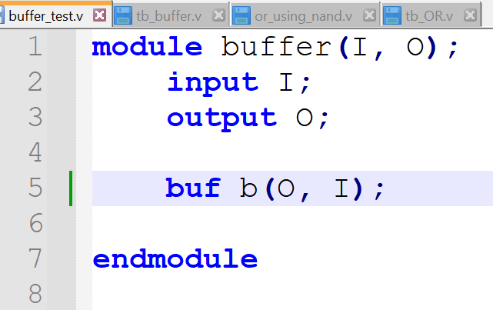

Test Bench:
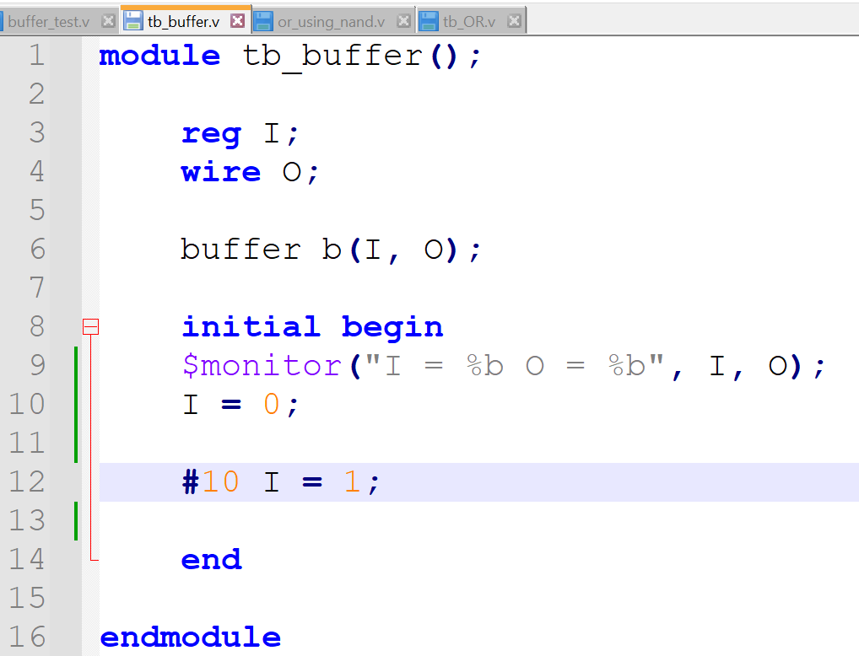
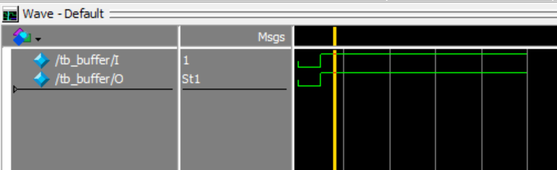
Output:
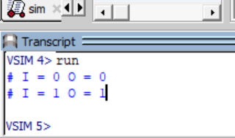

Task 2:
Implement an inverter at the gate level.
Code:
DUT:
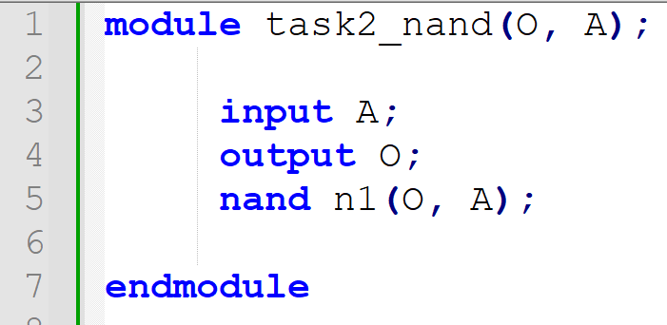
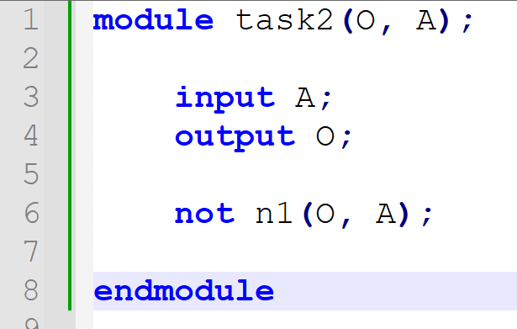

Test Bench:
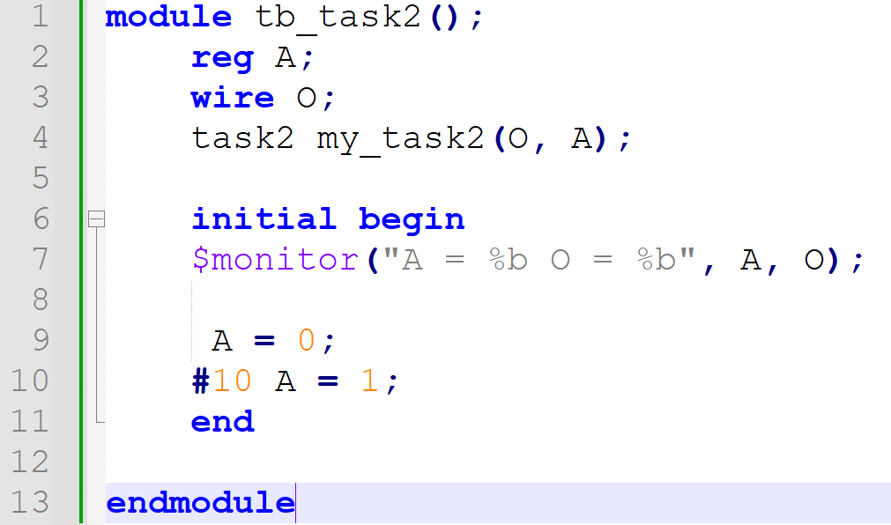
Output:
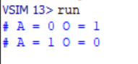
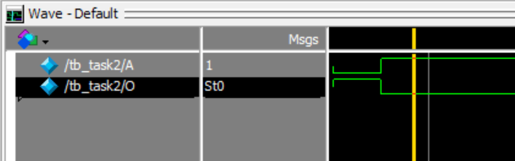

Task 3:
Implement an OR gate using a NAND gates.
Code:
DUT:
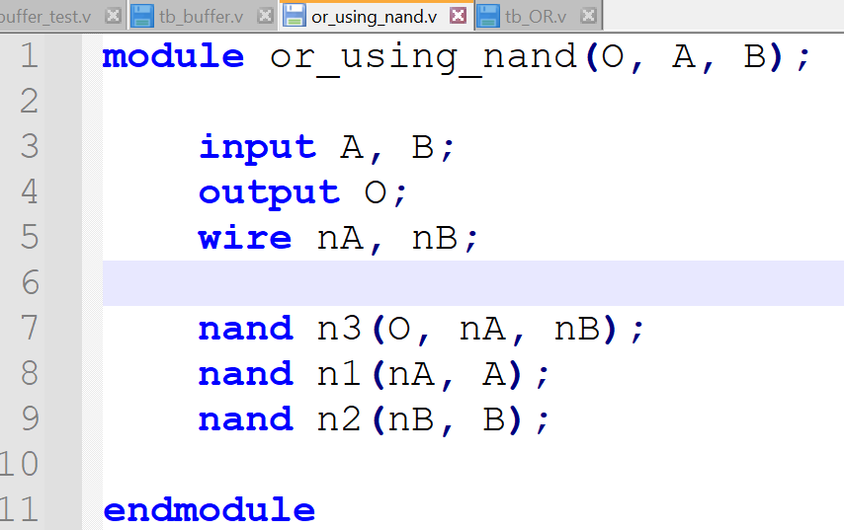

Test Bench:
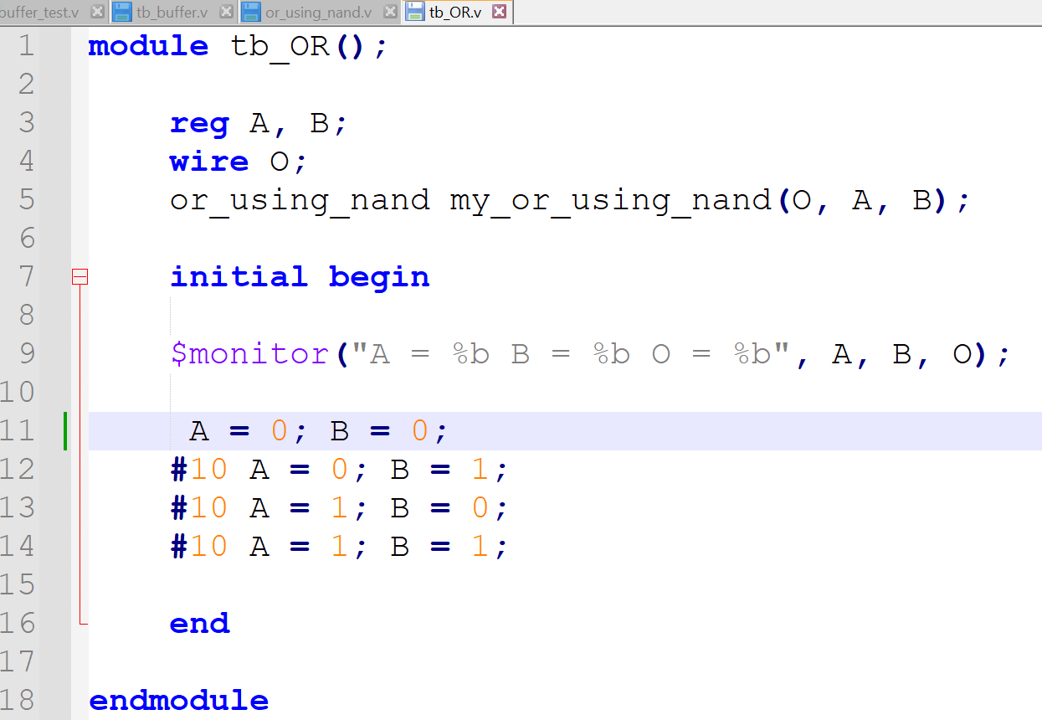
Output:
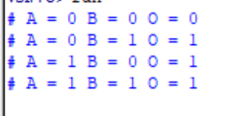
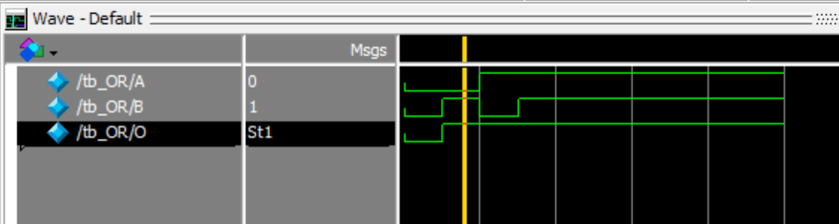

Task 4:
Implement the following equation where z is output and x1, x2, x3, x4, and x5 are inputs of the circuit.
z = ( y1 + y2 )’
y1 = x1.x2 y2 = (x3.x4.x5)

Code:
DUT:
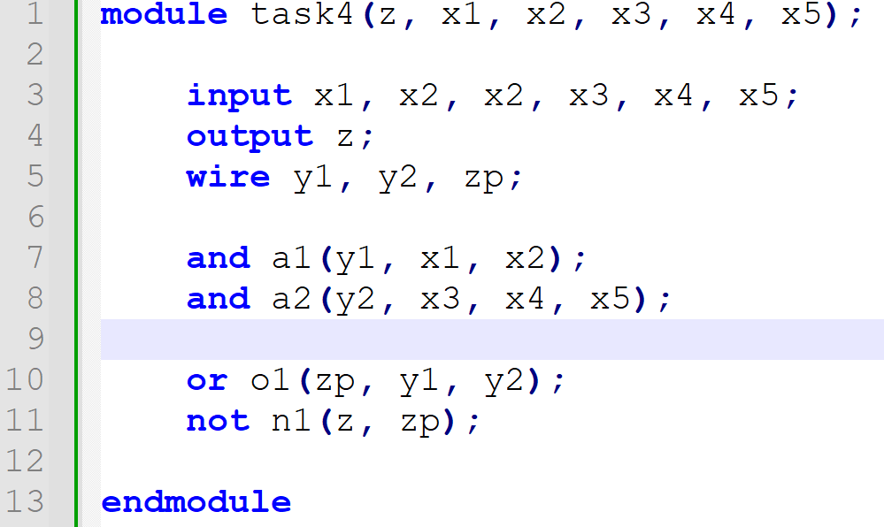

Test Bench:
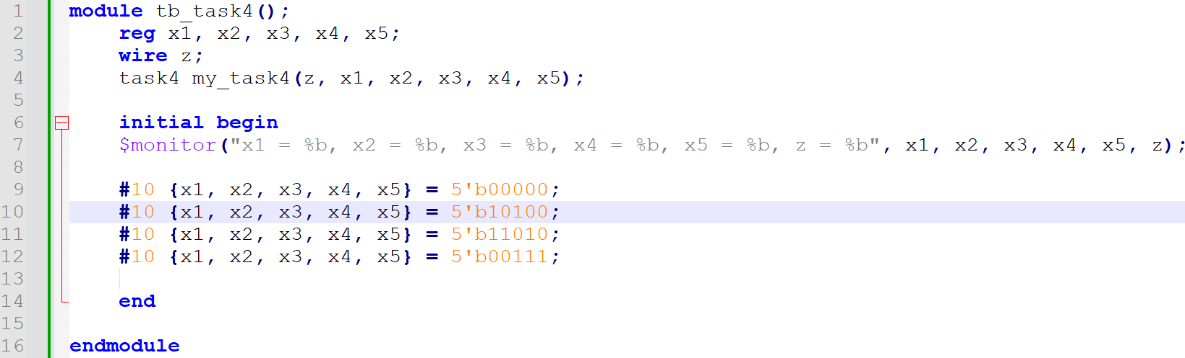

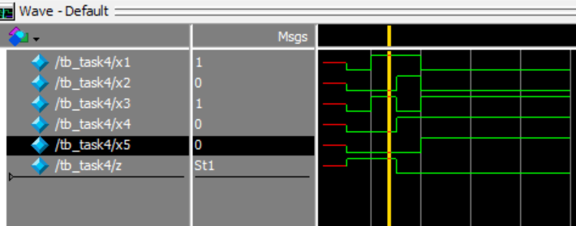
Output:
